**Ad Image Evaluation Metadata Requirements:**

Include all requirements of Ad Video evaluation metadata, but include ability to cut out and define all independent objects on the image. Examples below:

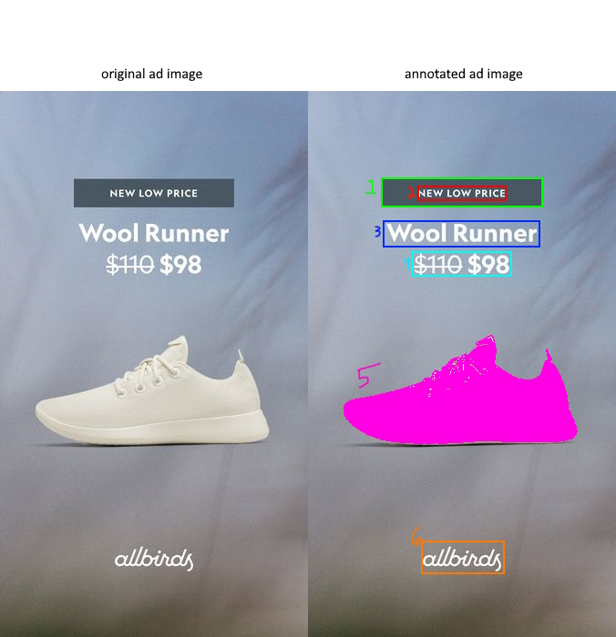

beyond normal annotation, 1 should be defined as a design element: rectangle, 2 as text in a design element, 3 and 4 as text normally, 5 as a shoe with realistic bounds, 6 as a logo , and 7 as the background (everything else)

Each element ideally should be able to be extracted as individual image assets for use in other images with none of the other elements attached

A list of ad images to test with are in this drive folder: <https://drive.google.com/drive/folders/1DB_VDsjZyxlCxCLNleYPzaVOMAknTY8A?usp=sharing>